**Amazon Rekognition Images:**

1. **Object and Scene Detection:** Identify all sorts of keywords that describe content in image.

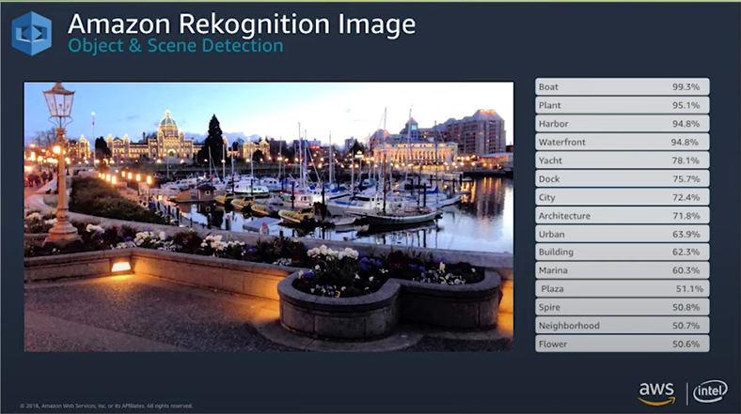

1. **Facial Analysis:**

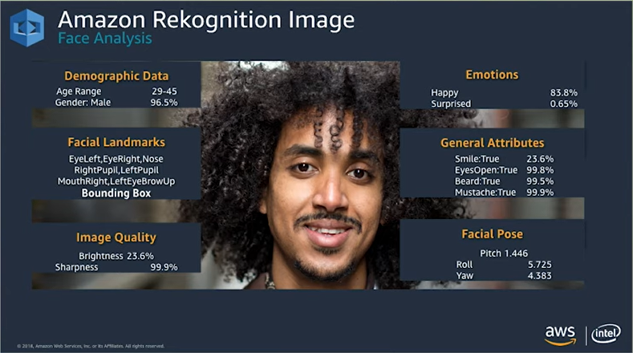

1. **Face Recognition:** Face similarity detection and searching, lets you match faces in an image against an index of faces that you have created or compare faces in one image against faces in another image. Rekognition will return a similarity score that determines the likely correctness of your match.

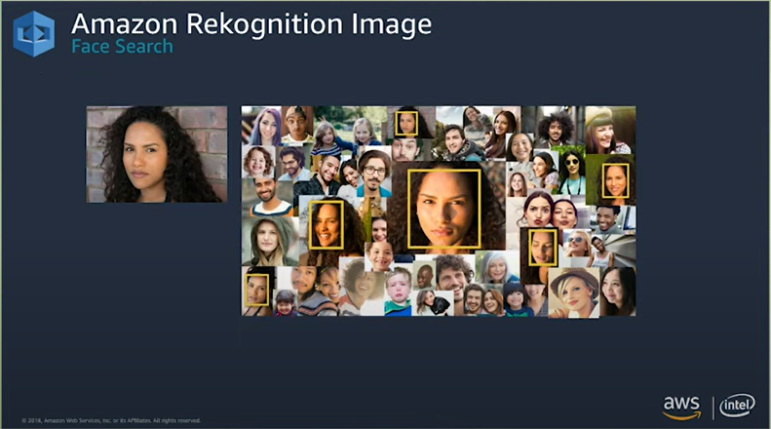

1. **Celebrity Recognition:**

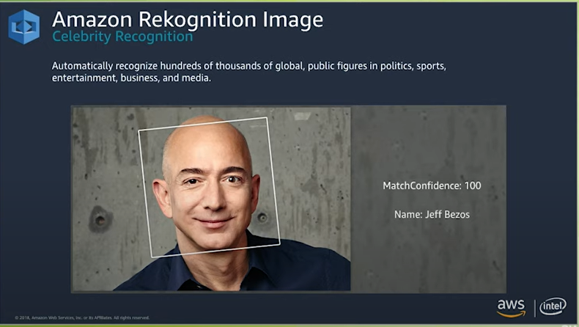

1. **Text in Image:** Returns all detected piece of text, both individually and as group of lines along with a confidence score for every detection

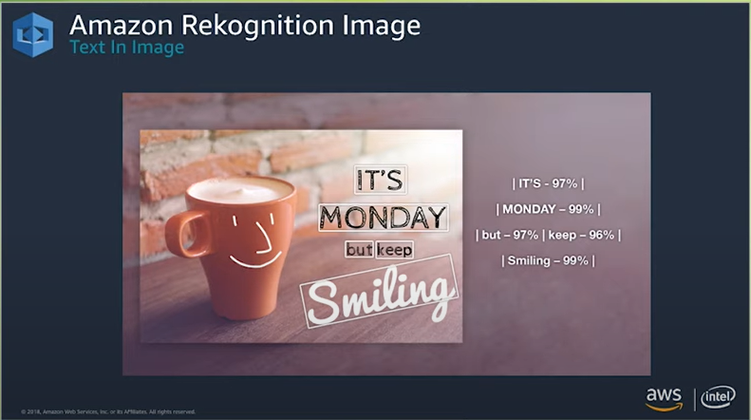

1. Unsafe Content Detection: Performs Image content moderation. Each moderation report includes a hierarchical list of moderation labels along with their confidence scores, giving insight into explicit or suggestive nature of content in the image.

There are two types of API operations : Non-storage, Storage based

* **Non-Storage API operations:** take input and return result without persisting any state
* **Storage based API Operations:** persist some information to AWS servers in order to let us make API calls that rely on this information.

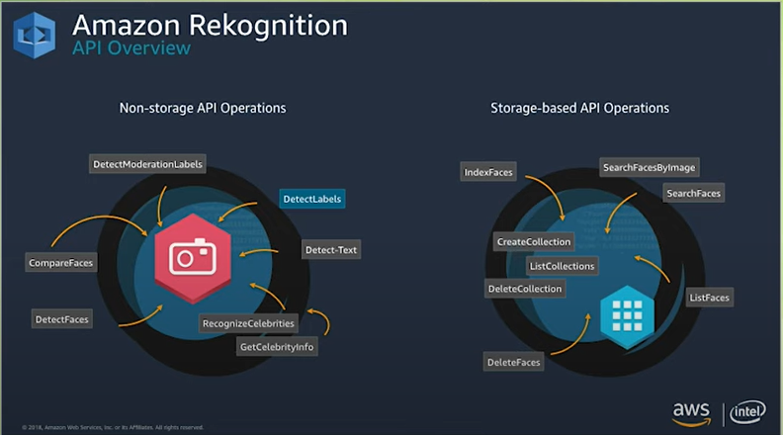

Applications using AmazonRekognition:

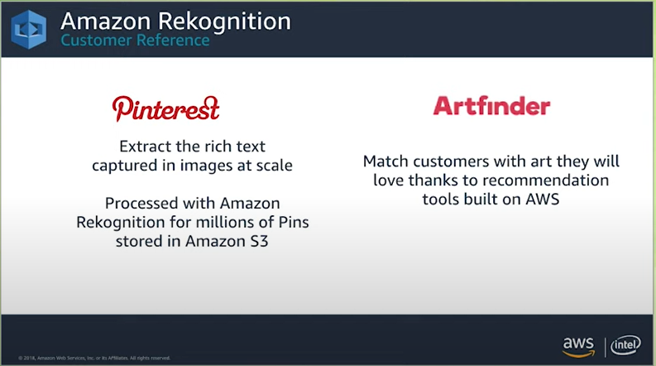

**Amazon Rekognition Video:**

We can use this on video files stored in S3 as well as Streaming Video service

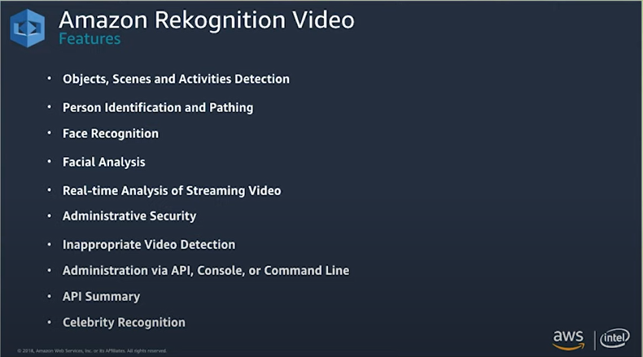

**Facial Analysis:**

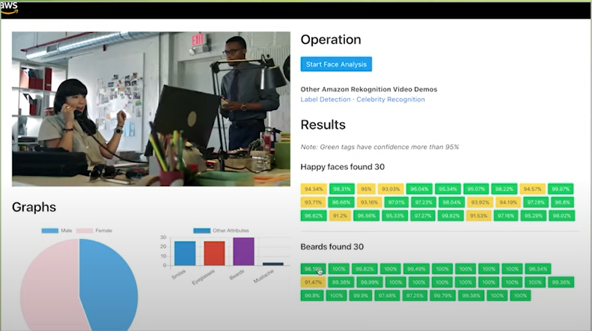

Here it represents, there are 30 happy faces and 30 beards found in this video. Each of the buttons represent the timestamp to when that feature was found, value inside each button represents the confidence percentage. Graphs give some analysis of different facial features like Smiles, Eyeglasses, Beards, Mustache. Also a visualization of Male/Female ratio.

Celebrity Rekognition:

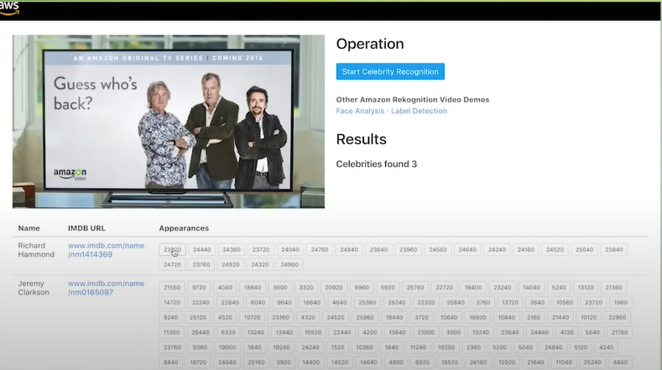

Returns the list of celebrities detected in the video with any relevant URLs for each celebrity and timestamps at when they were recognized.

Object and Label detection

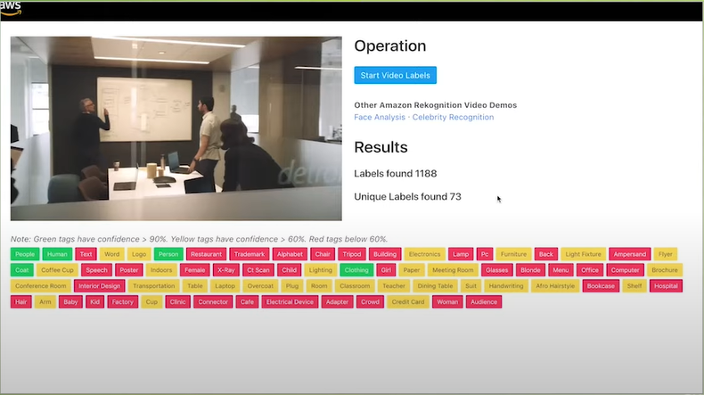

Person Identification and Pathing

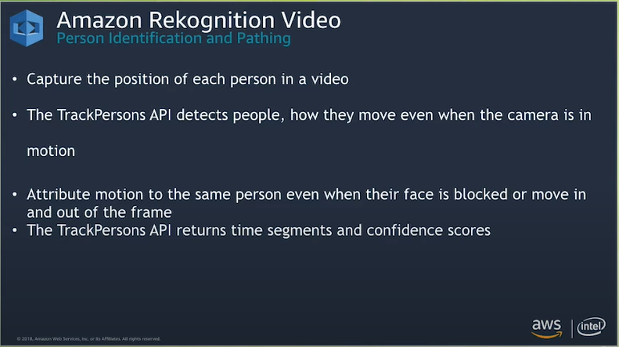

Video Streaming:

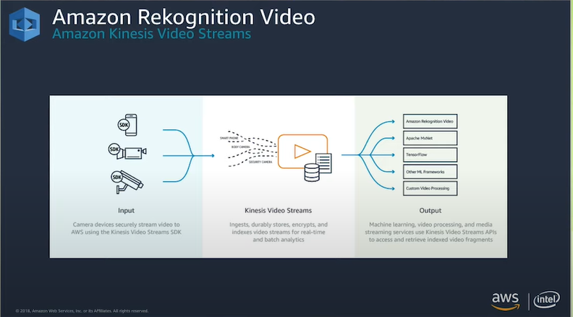

Uses Kinesis Video Streams SDK to stream videos to AWS and their perform necessary ML operations.

References:

1. AWS Innovate Online Conference 2018: <https://www.youtube.com/watch?v=v662kWVBmdc>
2. AWS sample codes: <https://github.com/aws-samples/amazon-rekognition-code-samples/tree/main/rekognition-apis>